USER ACCEPTANCE TESTING

|  |  |
| --- | --- |
| Date | 19 November 2022 |
| Team ID | PNT2022TMID22872 |
| Project name | Real –time river water quality monitoring and control system |

USER INITIATION

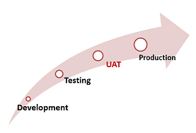

**User Acceptance Testing (UAT)**, or application testing, is the final stage of any software development or change request lifecycle before go-live. It is the final stage of any development process to determine that the software does what it was designed to do in real-world situations. Actual users test the software to determine if it does what it was designed to do in real-world situations, validating changes made and assessing adherence to their organization’s business requirements.

The main purpose of acceptance testing is to validate end-to-end business flow.

User Acceptance Testing is carried out in a separate testing environment. A change, an update, or a new feature is requested and developed. Unit and integration tests are run. All seems to be in order. But then, after it is released to the public, serious problems appear. Rework and retesting are not the most expensive consequences when that happens. Loss of reputation is.

